EECS 493

User Interface Development

Fall 2021

Final Exam

This is a closed-book, individual exam. There are five parts.

**Unless explicitly said, multiple-choice questions have only one correct answer.**

1. For questions requiring only one answer, multiple answers will be graded as wrong. E.g., if the correct answer is A. If you answered A, you got 2 points. AB is 0 points.
2. For questions that explicitly ask you to select 2 options. E.g., if the correct answer is AB. AB is 2points. ABC is 1 point. ABCD is 0 points. BC is 0 points.

Please put your choice **in the blank**.

Please **write your name and unique name on each page** (not the UM ID). We are going to take each exam page apart for grading.

Do not write anything outside the top-left staple, the staple corner will be cut off.

Rock it!

**Table of Contents**

UI Design Concepts (14pts)

UI Programming (Javascript) (14pts)

Vue.js (UI Architecture, MVC, Framework/Library/Tool, Vue) (20pts)

User-Centered Design (40pts)

Accessible and Universal Design (12pts)

# UI Design Concepts (14pts)

1. _____ When developing user interfaces, we need to consider human capabilities and limits. Which of the following is NOT correct about human capabilities that may influence UI design? (2pts)
2. One’s working memory can only hold a certain amount of information so that UIs should not create overloads to users’ working memory.
3. According to Fitts's Law, it’s better to make the command buttons of UI bigger in size than other non-interactive elements.
4. To give users a sufficient sense of control and freedom, it’s better to ask users to type the function they are looking for than providing a menu.
5. Since users process visual and auditory information through different channels, it’s better to present users with images plus narrations than images with captions.
6. (6pts) Consider which UI design property the following examples are addressing. Put the corresponding letter in the blank. Please note that each question has only **one** answer. **Options can be reused.** Each blank is worth 1.5pts.

Efficiency (E): can you get the job done quickly + well?

Understandability (U): do you understand what’s happening and why it’s happening?

Discoverability (D): can you find new UI features?

Learnability (L): can you learn to use the interface quickly?

1. My Amazon Echo just had some new intelligence, it’s able to help me create a shopping list. I ask “Alexa, what’s the weather”, after it answers my question, in addition it says “By the way, I’m able to help you create a shopping list”. This is addressing _______
2. On Youtube, I can create a playlist of my favorite videos so I don’t need to look for these videos each time. This is addressing _______
3. In the Starbucks app, I can see my recent orders and buy the same item again. This is addressing _______
4. Google maps has a new feature allowing people to view COVID cases on the map. It shows the new feature on the landing page of Google Maps for users that haven’t clicked it before (as shown below). This is addressing _______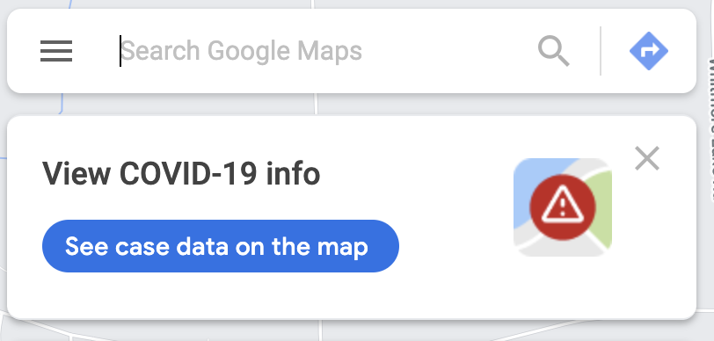
5. (6pts) Please put **one** corresponding option in the right column. Each blank is worth 1.5 pts. Please note each blank has only **one** answer. **Options can be reused.**

Affordance (A)

Signifier (S)

Metaphor (M)

Evaluation (EV)

Execution (EX)

| Statement | Answer |
| --- | --- |
| Example: I’m able to host virtual meetings through Zoom. This is a(n): | Example Answer: A |
| In Zoom, to let users know they can share screen, the button below is a(n) |  |
| In Zoom, I know I’m sharing the screen from the message at the top of the interface. This is addressing the Gulf of: |  |
| In Slack, when I see the button (right of the image), I know I can create a new message by clicking it. This is a good signifier because it is a(n): |  |
| In Google Maps, after I land on the page, I immediately see the search bar. This is addressing the Gulf of: |  |

# 

# UI Programming (CSS, Javascript, JQuery) (14pts)

1. ______ Which of the following is NOT correct about UI programming? (2pts)
2. UI programming relies on the user to “tell” the system what to do, e.g., through pushing a button or typing a text.
3. UI programming is similar to programming in Java or C++, in which developers have full control on which lines of code will be executed.
4. UI programming invites user input. The user is able to change the flow and logic of the system on the fly.
5. In UI programming, we may allow users to make direct manipulation of the interface elements, e.g., change layouts on the fly.
6. ______Which of the following is NOT correct about asynchronous programming in JavasScript? (2pts)
7. Running complex computation in the stack may have the risk of blocking the event loop, thus making the interface less fluid.
8. The event loop is constantly running and checking, when the stack is empty it pushes methods from the callback queues to the stack.
9. WebAPI functions such as ajax(), setTimeout() are added to the event loop where they wait to be pushed to the stack.
10. WebAPIs, event loop and callback queues all work together to allow asynchronous programming with JavaScript.
11. ______Which is NOT correct about JSON? (2pts)
12. JSON is unable to represent functions, dates, or shared object references.
13. It is good practice to give unique IDs to Javascript objects when generating JSON to be able to reference it later.
14. If my Javascript object references another object, when generating JSON, it includes the referenced object.
15. JSON is widely used to pass data between frontend and backend in web programming, because JSON is a complete representation of Javascript objects.
16. (4pts) Read the following code:

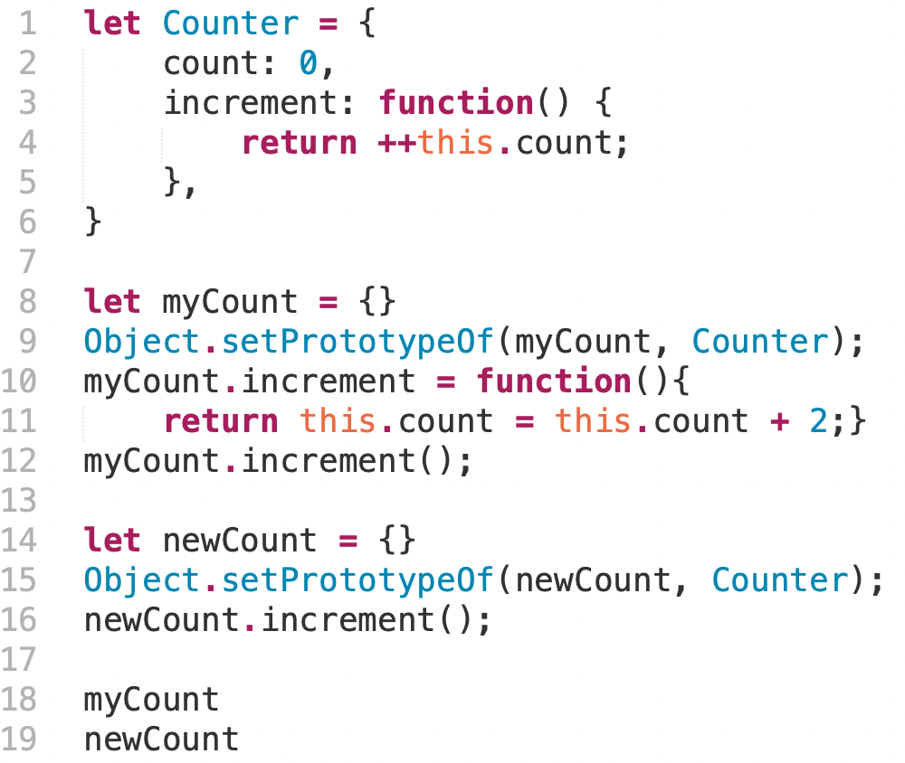

Hint: Object.setPrototypeOf(myCount, Counter) sets Counter to be the object myCount’s prototype.

1. _____What are the public properties of the object myCount? (2pts)
2. Count with the value of 2, a function increment
3. Count with the value of 1, a function increment
4. Count with the value of 2
5. Count with the value of 1
6. ____What are the public properties of the object newCount? (2pts)
7. Count with the value of 2, a function increment
8. Count with the value of 1, a function increment
9. Count with the value of 2
10. Count with the value of 1
11. (4pts) Consider the code below and the user interaction scenario.

The user loads the page at 9am. After exactly one minute (9:01), the user clicks the “Click Me!” button on the page.

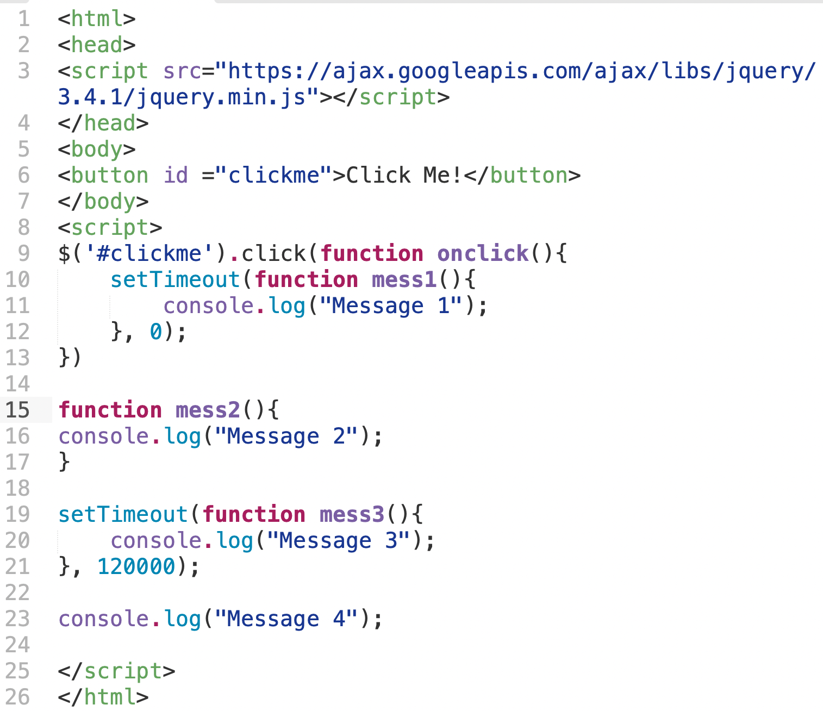

Please describe what happens **in the callback queue** between 9 and 9:03. You only need to describe what happens in the callback queue. You don’t need to describe what happens in the console.

Consider follow the template,

After [*the page loads*], [*method m0()*] enters the callback queue, [*method m0()*] exits the callback queue.

Answer:

# 

# 

# Vue.js (UI Architecture, MVC, Framework/Library/Tool, Vue) (20pts)

1. (2pts) A user Pat saw the following screen in Chrome on a laptop.

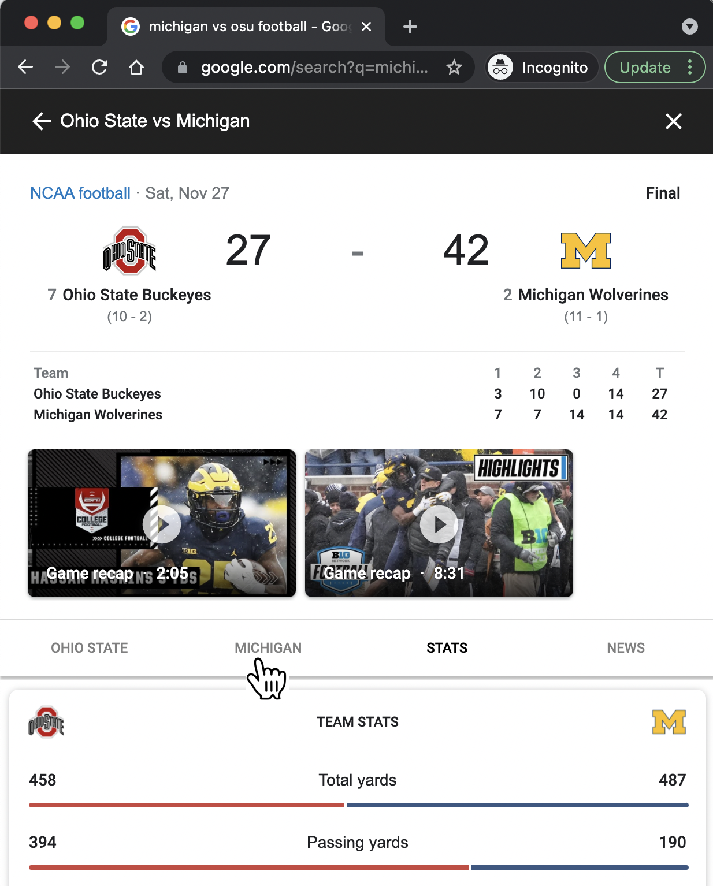

**Pat moved their cursor to the tab “MICHIGAN”, clicked, and saw information displayed under this tab.**

_______Which of the following are correct descriptions of what happens to the browser process and the renderer process in this scenario (**Please pick 2**)?

1. When Pat moves their cursor to the tab “MICHIGAN”, the renderer process captures the location of the cursor, and handles the Javascript events to display the information under this tab.
2. When Pat moves their cursor to the tab “MICHIGAN”, the browser process takes the location of the cursor and passes it to the renderer process.
3. The render process paints the front-end of the web page, however, it doesn’t process Javascript code. Javascript events are handled by the GPU process.
4. The renderer process handles Javascript events and renders the web page.
5. Answer the following two questions on Library/Framework/Tool (4pts)
6. Django is a python-based free and open-source solution for creating complex, database-driven websites. Django consists of an object-relational database (“Model”), a web templating system (“View”), and a regular-expression-based URL dispatcher (“Controller”). Django emphasizes reusability and the “pluggability” of components.

Django is a _______ (1pt)

1. Library
2. Framework
3. Tool

Please explain why. (1pt)

1. Scitkit-learn is very helpful for my machine learning projects. When I’m using python to analyze large datasets, I can use algorithms from scikit-learn. It features various classification, regression, and clustering algorithms that I can use in python.



_______Which of the following is correct about scikit-learn (2pts)?

1. It is a library because it has a collection of functions that help people do machine learning, but it doesn’t define how developers should structure their program.
2. It is a tool because it doesn’t interfere with the code structures. It provides support for users to analyze large datasets using machine learning algorithms.
3. It is a framework because it is language specific and controls what happens. Developers will fill in slots.
4. ________Which of the following is correct about why we want to use front-end frameworks such as Vue or React in web development (2pts)?
5. It helps reduce the amount of explicit coordination between model, view, and controller.
6. It helps separate the developing efforts on model, view and controller, but it does not reduce the coordination between them.
7. It helps speed up the rendering of web pages.
8. It helps create a one-to-one mapping between model and view, so that it is more friendly for novice programmers of UI.

# 

# 

# 

# 

# 

# Intentionally Left Blank

1. (12pts) Complete the following program using Vue.js framework.

Here’s what the HTML page looks like in the browser. When a user hovers over the color boxes, the Tshirt image updates. When the user presses “Add to Cart”, the number in “Cart” increases, the number “Item left” decreases. When “Item left” is 0, the button is disabled.

Here’s relevant CSS code for the website.

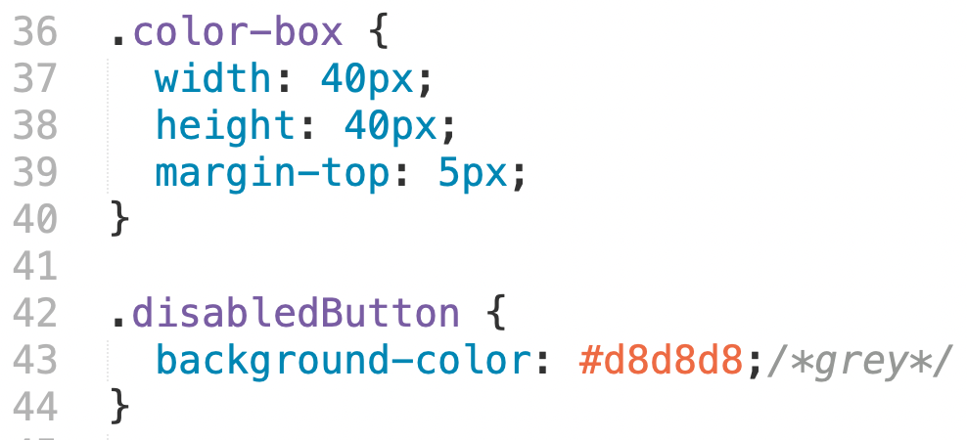

Here’s the Vue.js code

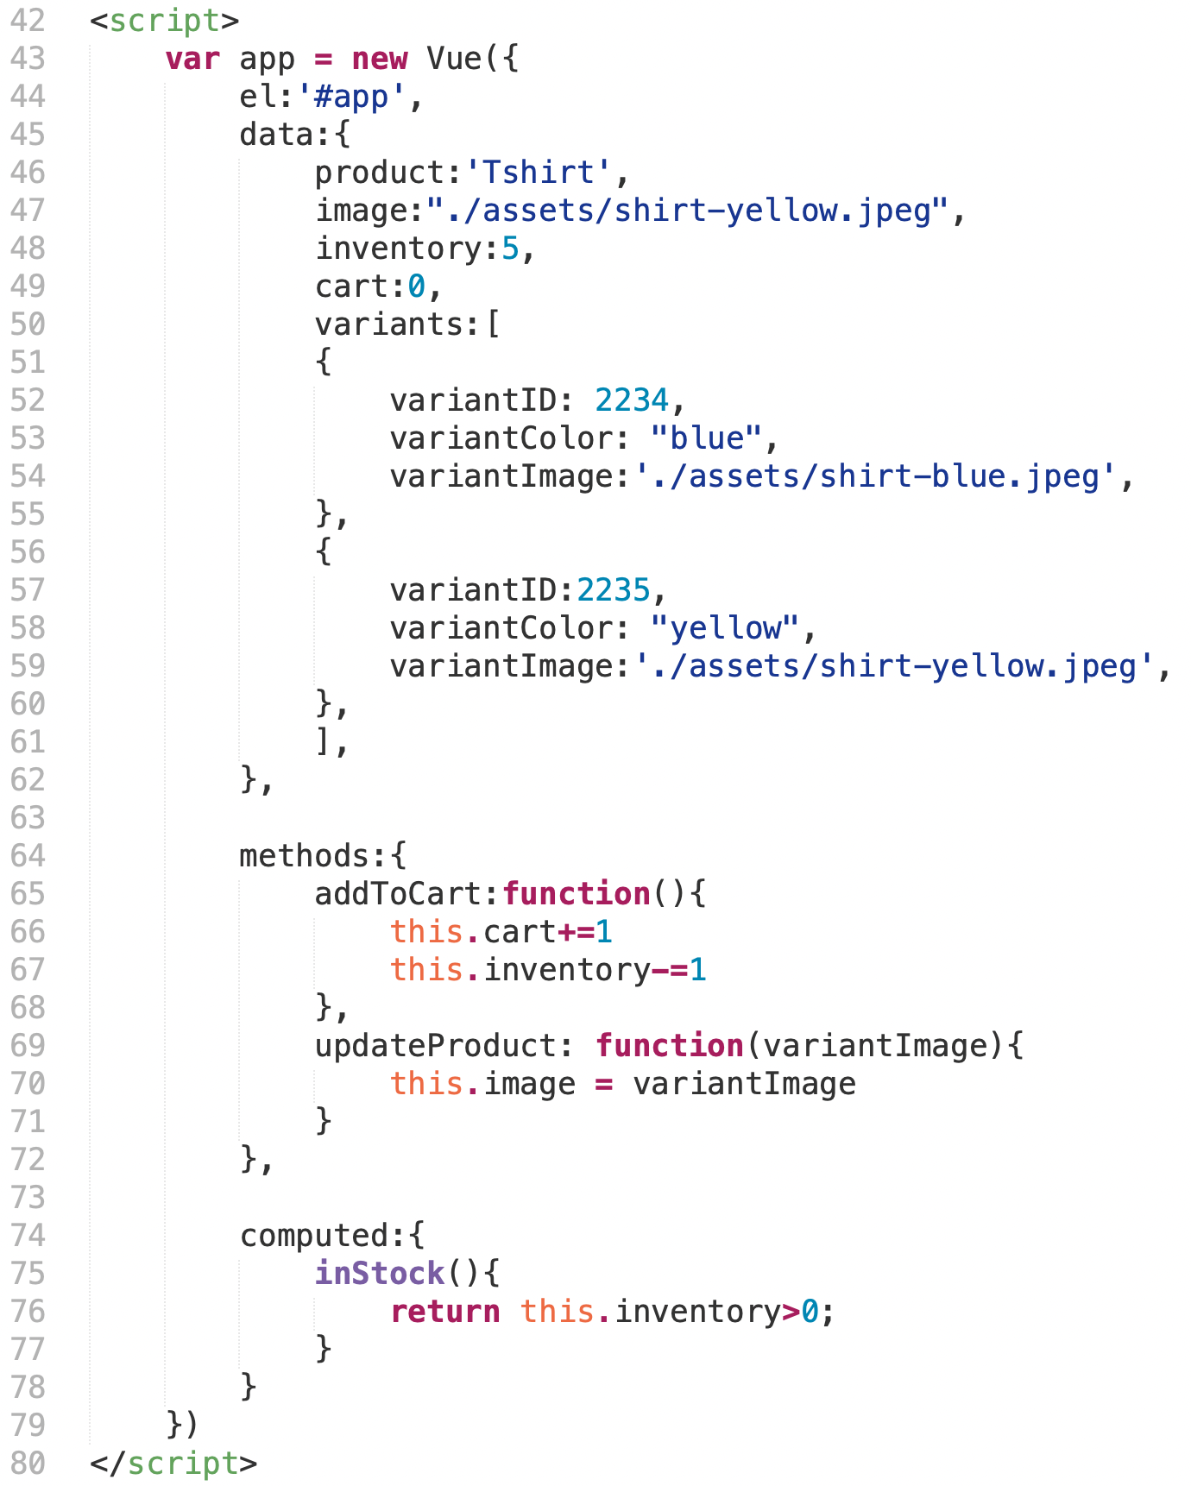

# 

# 

# 

# 

# 

# Intentionally Left Blank

# 

Here’s what the HTML page looks like in the browser

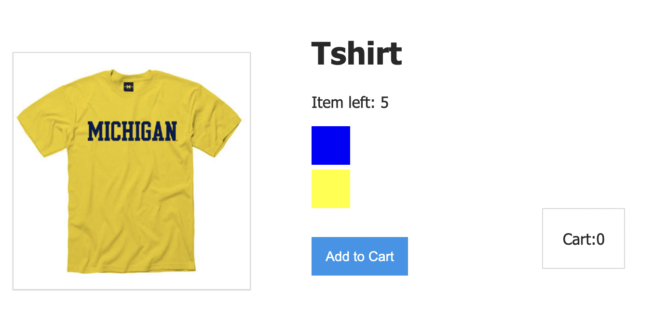

**Please use the following options to complete the HTML code on the next page. Each blank is worth 1pt. Not all options will be used.**

1. <div id = “app”>
2. <div class = “app”>
3. {{product}}
4. {{data.product}}
5. {inventory}}
6. {{data.inventory}}
7. <img v-bind:src=”image”>
8. <img src = ‘./assets/shirt-blue.jpeg’>
9. class = “color-box”
10. style = “color-box”
11. v-for = “variant in variants”
12. v-bind:key = “variant.variantID”
13. v-bind:style = “variant.variantColor”
14. v-bind:style = “{backgroundColor: variant.variantColor}”
15. style = {{variant.variantColor}}
16. @mouseover = “updateProduct(variant.variantImage)”
17. v-on:click=”addToCart”
18. v-on:click=”updateProduct”
19. v-bind:class= “{disabledButton : !inStock}”
20. class=disabledButton
21. {{cart}}
22. {{inStock}}

<body>

1____________

<div class = "product">

<div class = "product-image">

2__________________

</div>

<div class = "product-info">

<h1>3__________</h1>

<p>Item left: 4___________</p>

<div 5____________

6____________

7____________

8____________

9____________>

</div>

<button 10___________

11___________ >Add to Cart</button>

<div class ="cart">

<p>Cart: 12__________</p>

</div>

</div>// div product info

</div> //div class product

</div>

</body>

# 

# User-Centered Design (40pts)

1. (6pts) Inspect the following user-centered design and development scenarios. Assuming you are the chief designer on the project. For each scenario, please determine which method from the list below would be the most appropriate and explain why. Please write the corresponding letter in the blank.

| A. Observation | B. Think Aloud Protocol | C. Semi-Structured Interview | D. High-fi Prototyping | E. Heuristic Evaluation |
| --- | --- | --- | --- | --- |

1. Your team is considering building a social fitness app that encourages users to exercise with their friends and share fitness data among friends. Before building the app, your team wants to understand users’ preferences and concerns around privacy e.g., why they want or don’t want to share fitness data.

Method (1pt): __________

Reason (1pt):

1. Your team wants to build cooking devices for blind people. Before you start, your team wants to understand blind people’s natural cooking behaviors at home.

Method (1pt): __________

Reason (1pt):

1. Your team built a music recommendation app that allows users to socialize with each other. Your team just finished a high-fidelity prototype and want to inspect the usability of the app. Your goal is to inspect lower-level usability bugs that can be quickly fixed before you recruit users.

Method (1pt): __________

Reason (1pt):

1. (6pts) Inspect the following user-centered design and development scenarios. Assuming you are the chief designer on the project. For each scenario, please select which is the best method to use.
2. Your team designed a new feature in a social media app X_Xchat. Your team found the feature was very well received by users in Michigan. However, users in California didn’t use the new feature as much. Your team wants to know why users in California didn’t use the new feature.

________Which is the most appropriate method to use and why? (2pts):

1. Observation because the goal is to observe users’ natural behaviors when they use X_Xchat, especially for users who are in California.
2. Semi-structured interview because the goal is to let users in California share their experiences on the new feature, why or why not they used them.
3. Think-aloud protocol because it’s important to understand users’ intentions and investigate whether users’ could complete tasks as they navigate X_Xchat.
4. Heuristic evaluation because it’s important to understand which factors are preventing users from using the new features.
5. High-fi prototyping because a prototype is necessary for further evaluation of why users don't’ like the new features in X_Xchat.
6. Your team built a bus route recommendation app that allows UM students to find the fastest route between two points on campus. Your team just finished a functional prototype and wanted to understand how UM students will use the app to find routes.

________Which is the most appropriate method to use and why? (2pts):

1. Observation because the goal is to observe how UM students in general find bus routes and what challenges they have in finding bus routes.
2. Semi-structured interview because the goal is to let UM students share their experiences finding bus routes across campus.
3. Think-aloud protocol because it’s important to investigate whether users could successfully complete the task in the app.
4. Heuristic evaluation because it’s important to understand which factors are preventing users from successfully completing a task using the app.
5. High-fi prototyping because a prototype is necessary for further evaluation of how UM students may use the app to find bus routes.
6. Your team is building an online meeting platform that provides better support for meeting participants to take notes. After storyboarding, you decided on a list of functionalities that your platform will provide. Your goal now is to figure out the task flows of your platform, the color scheme, and the transitions between different tasks.

________Which is the most appropriate method to use and why? (2pts):

1. Observation because the goal is to observe how users take notes during online meetings.
2. Semi-structured interview because the goal is to let users share their experiences about their note taking behaviors during online meetings.
3. Think-aloud protocol because it’s important to ask users to think out loud while they take notes during online meetings to understand their intentions and challenges.
4. Heuristic evaluation because it’s important to understand which factors are supporting or preventing users from taking notes in the new platform.
5. High-fi prototyping because a prototype is necessary for further development and evaluation of the platform.
6. Please describe one rule for the initial phase of ideation in human-centered design (2pts)
7. _________Which of the following is correct about the commonality and difference between ideation and prototyping (2pts)?
8. Ideation and prototyping are two completely distinctive processes, since ideation is about brainstorming and prototyping is a concrete visualization of the ideas.
9. Ideation and prototyping often go hand in hand. The goal of these processes is to help the team get feedback in early stages of the design cycle.
10. Ideation doesn’t require user feedback, whereas feedback is critical in prototyping.
11. Ideation happens at an early stage in user-centered design, whereas prototyping happens later which requires that the developers are certain about the features to include in the product and implement them.
12. Your design team is building an AI-powered robot to help cultivate curiosity in kids. Before the AI capabilities are complete, you want to make design decisions on how kids could interact with the robot.

________Which of the following prototyping methods would you use (1pt)?

* 1. Wireframe
  2. Wizard-of-oz
  3. Storyboards
  4. Paper prototypes

Please explain why (1pt):

1. Your design team is interested in developing technologies to support collaborative learning in 8th grade classrooms. You brainstormed 50 ideas and wanted to quickly test which ideas teachers like or not like.

________Which of the following is the best description of which method to use and why? (2pts):

1. Wireframe because teachers need a visual representation of the user interface to understand its functionality.
2. Wizard-of-oz because it gives teachers initial experience of the different characteristics of the technologies to support collaborative learning in classrooms.
3. Storyboards because it allows the team to get rapid feedback on teachers’ reactions on the ideas.
4. Paper prototypes because it’s cheaper and quicker compared to wireframes and is especially useful for feedback at early stages of development.
5. _______Which of the following is NOT correct about cognitive walkthrough (2pts)?
6. Cognitive walkthrough is fast and cheap, and easy for software developers.
7. It is especially useful as a group activity, because it supports ideas exchange from the perspectives of both designers and developers and increases buy-in.
8. It’s hard to gauge the severity of issues using this approach.
9. It’s the most effective in helping developers find how experienced users use the software instead of novice users.
10. Identify one upside and one downside of the method *Think-aloud Protocol.*

Upside (1pt):

Downside (1pt):

1. ______During a think-aloud, which of these would you do if a participant gets stuck on a task for 5 seconds? (2pts)
2. Tell the participant how to move forward
3. Wait longer before intervening
4. Ask the participant to describe why they get stuck
5. End the task early
6. During a think-aloud, if you see a participant do something unexpected and you want more information about why they did it, what should you do? (2pts)
7. _________During a think-aloud, what is one good way to encourage a participant to talk? (2pts)
8. Say “please explain”
9. Say “please keep talking”
10. Start asking questions
11. Remind the participant to talk every 2 mins.
12. When a designer is getting prepared for conducting a think-aloud, it’s important to select a task. Please describe one rule/tip for task selection. (2pts)
13. Pretend you asked two participants to practice thinking aloud by solving the math problem below. Which participant’s response is better, and why? (2pts)

197

+55

**Participant A:** Well first I start with the ones column, so I’m going to add 7 and 5, which makes 12. Then I’m going to write the 2 as the ones digit of my answer, then there’s an extra 10. So I have to carry the 1 and write it above the 9. Now I’m going to add 1 and 9 and 5, which makes 15. So again I’m going to write the 5 in the answer digit and carry the 1 over to the hundreds column. Now I have to add 1 and 1, which is 2, so I’m going to write the 2 below. Then I have an answer of 252.

**Participant B:** Well 7 and 5 is 12. The 2 goes down here and carries the 1. 1 and 9 and 5 is 15. The 5 goes down here and carries the 1 again. 1 and 1 makes 2, so it’s 252.

Answer (1pt): ______

Why? (1pt)

Here is a set of Nielsen’s heuristics from Heuristic Evaluation. These will be used for the next two questions.

| H-1: Visibility of system status  H-2: Match between system & real world  H-3: User control & freedom  H-4: Consistency & standards  H-5: Error prevention | H-6: Recognition rather than recall  H-7: Flexibility and efficiency of use  H-8: Aesthetic and minimalist design  H-9: Help users recognize, diagnose, recover from errors  H-10: Help and documentation |
| --- | --- |

1. (3pts) Apply heuristic evaluation. Examine the screenshot below from ebay.com (an e-commerce platform). Pat wanted to buy an item. They first checked the item description page and wanted to contact the seller of the item. After clicking “Contact the Seller”, Pat was directed to the following interface which asked Pat to enter the 12-digit item number. Pat didn’t remember and had to go back to the item description page to find out.

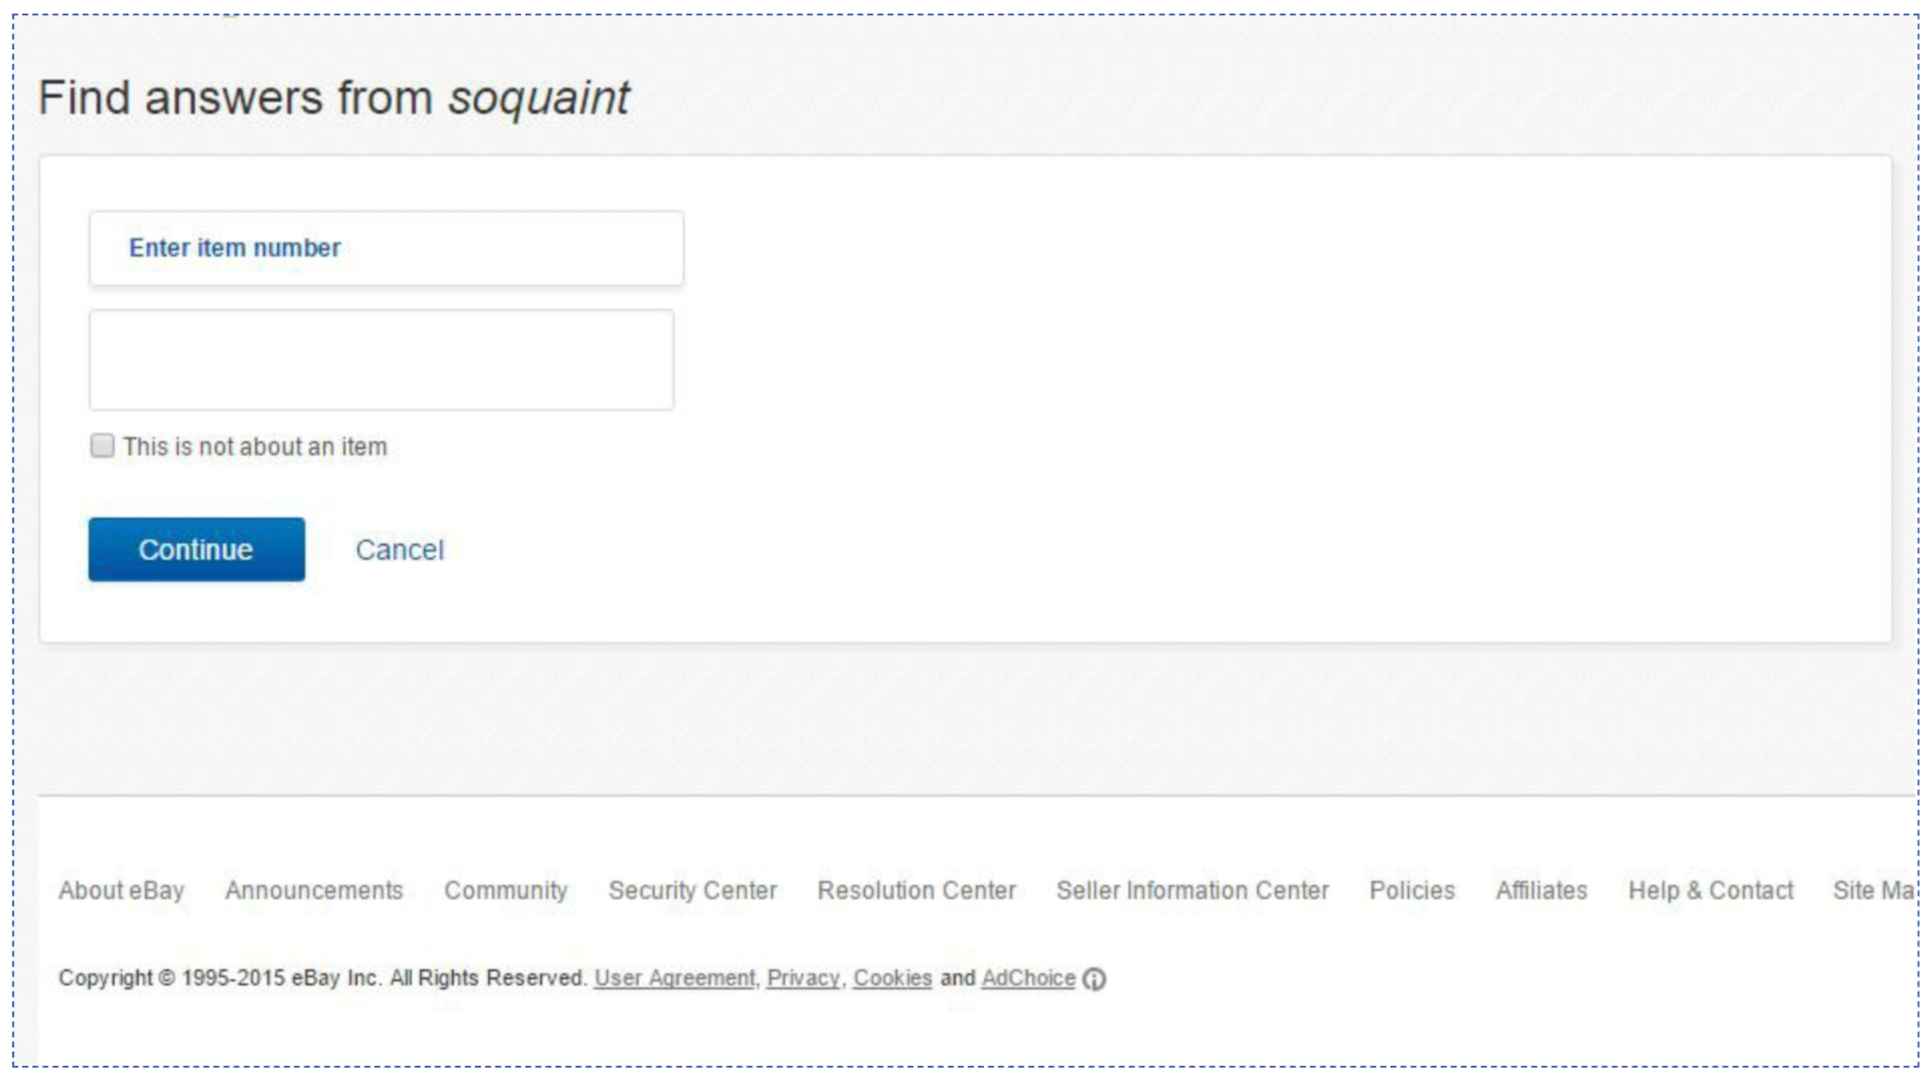

(a)Which is the most salient heuristic rule that this violates? (1pts)

(Write either the number, e.g. H-1, or the full text, please write **one** answer)

(b) ______Which of the following redesigns is the best to fix the problem you identified? (2pts)

1. On the item description page, include a blurb that says “please take a note of the item number for future reference of the item”.
2. On this page, provide a link to the item description page.
3. On the item description page, allow users to bookmark items for future reference. On this page, display all the item numbers the user has bookmarked.
4. On this page, provide a menu of the most recently viewed 3 items for the user to choose from.
5. (3pts) Apply heuristic evaluation. Examine the screenshot below from ebay.com (an e-commerce platform). Pat wanted to sell a book on ebay. They first entered the ISBN number of a book and clicked “get started”, the system didn’t give a confirmation message on whether the ISBN number was found and proceeded to the next step. In the next step, the system asked Pat to choose a listing form (i.e., fill out a form about the specifics of the listing. Pat was very confused.

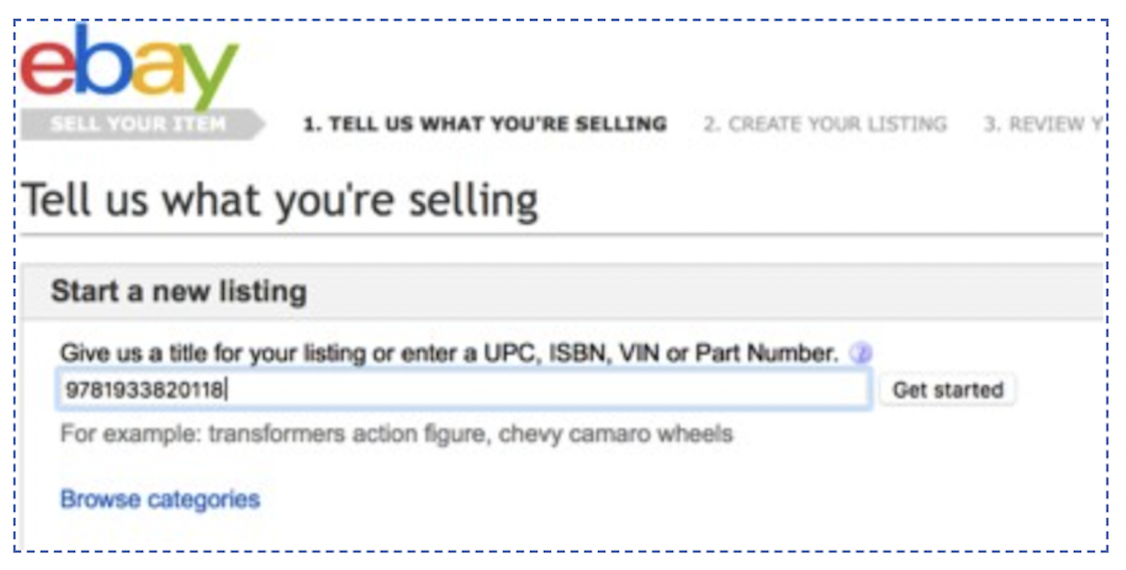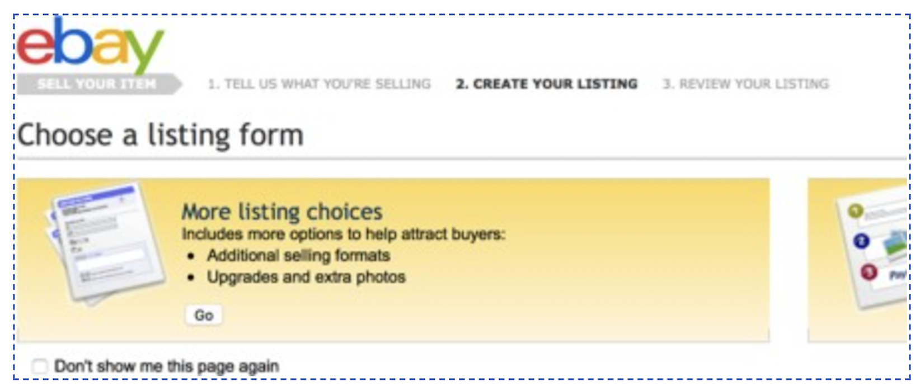

(a)Which is the most salient heuristic rule that this violates? (1pts)

(Write either the number, e.g. H-1, or the full text, please write **one** answer)

(b)Please propose a redesign to fix the problem you identified. (2pts)

# Accessible and Universal Design (12pts)

1. (4pts) Consider block-based programming, like Scratch.

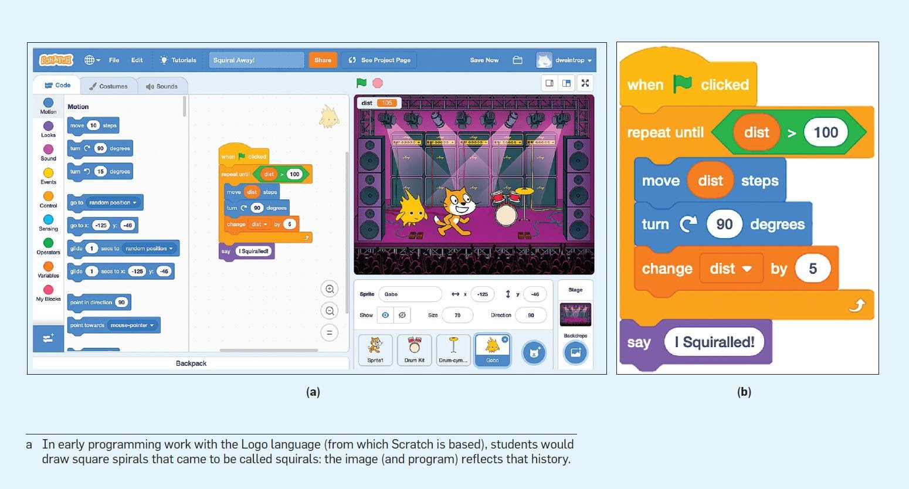

(a)For people with low vision, which one is more accessible? Block-based or textual programming?

Answer (1pt): _____

Please explain why (1pt):

(b)__________Which of the following is correct about the accessibility of textual programming and block-based programming for people with motor disabilities? (2pts)

1. Block-based programming is more accessible since it reduces the cognitive load required in programming.
2. Block-based programming is more accessible since it requires fewer motor movements.
3. Textual programming is more accessible since it requires less use of mouses which requires more precise movements and control, such as drag and drop.
4. Textual programming is more accessible since it relies on keyboards and enables users to use both of their hands.
5. (4pts) Consider how universal design principles are used in the following scenarios.

| A. Equitable Use  B. Flexibility in Use  C. Simple and Intuitive Use  D. Perceptible Information | E.Tolerance for Error  F. Low Physical Effort  G. Size and Space for Approach and Use |
| --- | --- |

(i) Ramp entrance

 

Design X Design Y

Your team moved from Design X to Design Y considering the universal design principles. Which design principle was the most highlighted in the transition? (Pick **one answer from the list above**) (1pt)

Please explain why (1pt)

(ii) Emergency stop key on treadmills

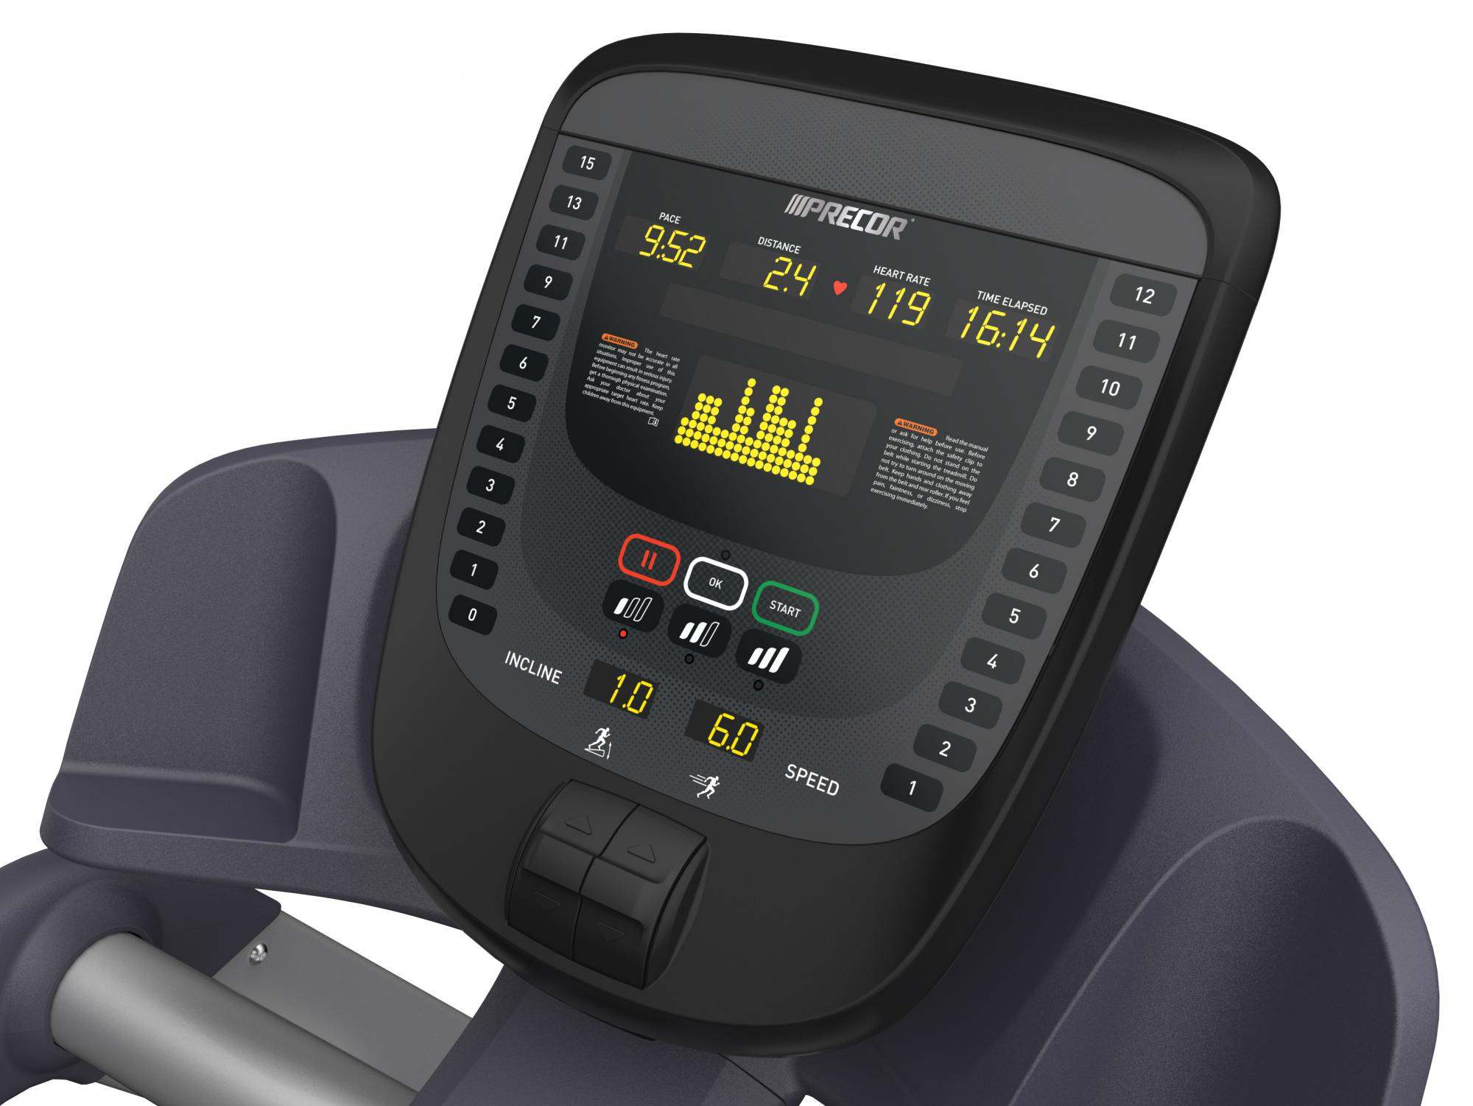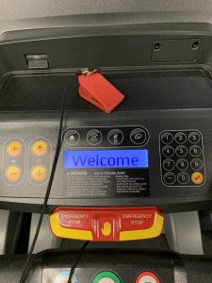

Design X Design Y

Your team moved from Design X to Design Y (added an emergency stop key) considering the universal design principles. Which design principle was the most highlighted in the transition? (Pick **one answer from the list above**) (1pt)

Please explain why (1pt)

1. (4pts) Consider how universal design principles are used in the following scenarios.

(i) Flat panel light switches

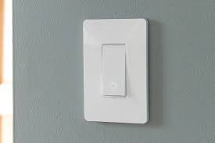 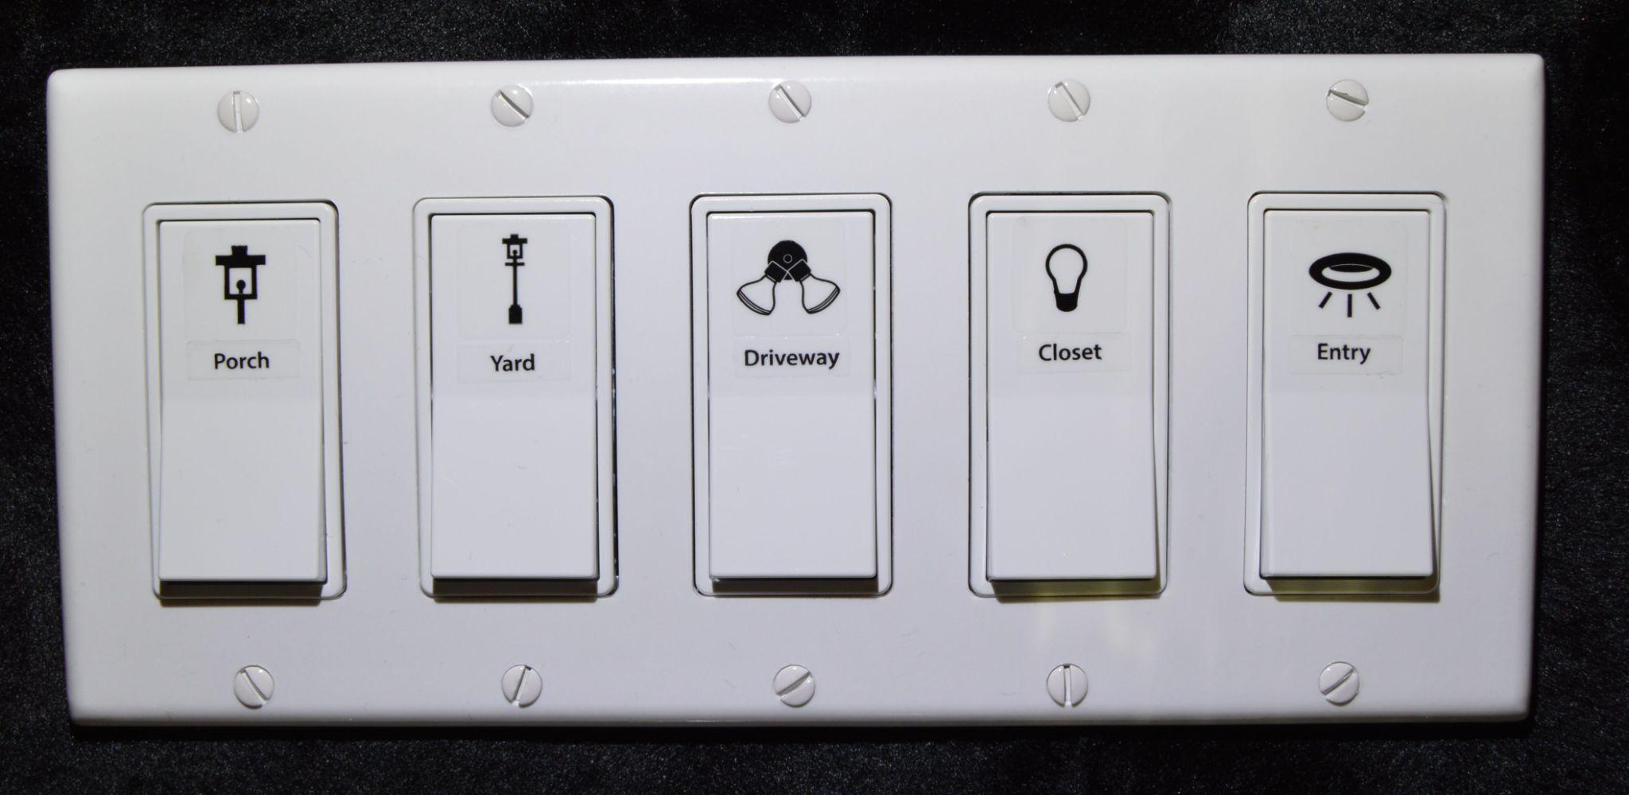

Design X Design Y

Your team moved from Design X to Design Y considering the universal design principles. Please select which universal design principle is the most highlighted in the transition and why (2pts)

Answer: ____________

1. Simple and intuitive use because it’s intuitive to users where they should press.
2. Perceptible information because the symbols and texts show what each switch is for.
3. Tolerance for error because the switches are easy to hit so it’s not likely that users will make mistakes.
4. Size and space for approach and use since the panel bar is of a bigger size, making it easier for people to press.

(ii) Reception desk

 

Design X Design Y

Your team moved from Design X to Design Y considering the universal design principles. Please select which universal design principle is the most highlighted in the transition and why (2pts)

Answer: ____________

1. Equitable use because people with different abilities can use the reception desk well.
2. Flexibility in use because users can pose different gestures at the reception desk.
3. Size and space for approach and use because people with different heights or body size can access the reception desk.
4. Perceptible information because Design Y provides additional patterns and signs to help users navigate the reception desk.

==========END============

Thank you and happy holidays!